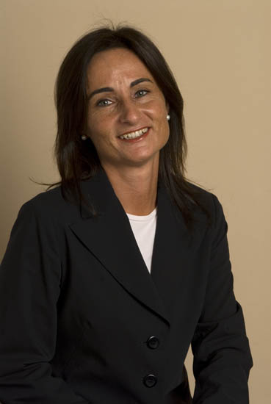 Laura BOSCOLO, Milan Rome Turin, Italy  2021-2025 Various trainings and learning experiences  2020-2021 Remote learning design, APPrendere  2019-2019 Six Seconds SEI Emotional Intelligence  2016-2019 MS Voice Dialogue, London, GB  2015-2015 Harvard Business School – Global Colloquium on Participant-  Centered Learning, USA  2013-2013 Solution Focused Brief Coaching, SolutionSurfers, USA  2009-2009 MS Shadow Coaching, SOSC, USA  2008-2009 MBTI 1 + 2, OPP, Italy  2006-2007 MS Executive Coaching, Academy of Executive Coaching, UK  2003-2006 MS Counseling, SiCo, Italy  1995-1995 PA Counsulting, PAPI Preference Inventory, Italy  1989-1990 MS UNICEF, Education to Development, Italy  1988-1994 MA Economics, Rome University, Italy | April 2025
Experience
Laura Boscolo is Affiliate Professor of Organizational Behaviour on the Executive EMBA of the European School of Management Italia (ESCP Europe), in Turin, as well as trainer, facilitator, Executive Coach and Counselor supporting global Corporations.
With more than 20 years experience in support activities and functions as Entrepreneur and Executive to major Global Corporations, Laura got a broad international experience in human resources management, development, training, recruiting, leadership, tutoring and mentoring as well as organizational development and consulting.
She has built up a broad experience in people development starting from her past as Executive in Global Corporations and international assignments for Underdeveloped Countries programs. She has lead and mentored over 30 Cultures and is an active volunteer in Africa co-operating with non-profit organization on self-development programs.

Areas of expertise

- Individual, Group and team coaching. Organizational Consultancy
Laura’s focus is on providing effective development coaching and training, strategic innovative thinking, successful change and leadership programs linked with business and personal benefits. She base her expertise on careers guidance and potential development, on the strong Corporate experience as on the marked skills on listening, understanding customer needs and intercultural relationship.
She is mainly focused on Executive Coaching and support of board teams and newly formed groups.

Client references
Laura’s clients are widely from diverse business areas as from Telecommunications and Media, Banking, Insurance, Pharmaceuticals, Technology, Automotive, Entertainment, Tourism, Cruising, Engineering and Energy Corporations. Due to her hetical beliefs she use not to share Clients names, but give transparency to areas and mode of interventions.

Coaching languages English and Italian.

Memberships
PWA – Professional Women Association;
CPC – Comunità di Pratica di Coaching (Communauté de Pratique de Coaching)

